**Dr. J. J. Magdum Trust’s**

**Dr. J. J. Magdum College of Engineering,**

**Jaysingpur.**



**Mini Project Report**

**Department of Computer Science & Engineering.**

**Shivaji University, Kolhapur**

**Academic Year: 2022-2023**



**Dr. J. J. Magdum Trust’s**

**Dr. J. J. Magdum College of Engineering,**

**Jaysingpur.**

**A Mini Project Report On**

**“Employee Database Management’’**

**Submitted by,**

**Name of Students: - Roll No.**

1. **Chavan Vaishnavi Sanjay 05**
2. **Bavannavar Prathamesh Uday 03**
3. **Jyothi Hrishikesh Venkatesh 21**

**Date: - / /2023 Prof. P. V. Kothawale**

**Place- Jaysingpur Project Guide**

**Department of Computer Science & Engineering**

**Year of Submission**

**2021-2022**

**Dr. J. J. Magdum Trust’s**

**Dr. J. J. Magdum College of Engineering,**

**Jaysingpur.416101**

**Department of Computer Science & Engineering.**



**Certificate**

This is to certify that the project report titled **“Employee Database Management”** submitted by,

**Name of Students: - Roll No.**

1. **Chavan Vaishnavi Sanjay 05**
2. **Bavannavar Prathamesh Uday 03**
3. **Jyothi Hrishikesh Venkatesh 21**

has satisfactorily completed the project entitled “**Employee Database Management**” in partial fulfillment for award of Bachelor of Engineering Degree in **Computer Science and Engineering** by Shivaji University, Kolhapur.

Prof. P .V. Kothawale Dr. D. A. Nikam

**Project Guide H.O.D CSE Dept.**

Dr. S. B. Patil

**Principal External Examiner**

**Dr. J. J. Magdum Trust’s**

**Dr. J. J. Magdum College of Engineering,**

**Jaysingpur.416101**

**Department of Computer Science & Engineering.**



**Certificate**

This is to certify that the project report titled **“Employee Database Management”** presented before Department Research Committee (DRC) by…

|  |  |  |
| --- | --- | --- |
| **Name of Students** | **Roll No.** | **Signature** |
| 1. **Chavan Vaishnavi Sanjay** | **05** |  |
| 1. **Bavannavar Prathamesh Udya** | **03** |  |
| 1. **Jyothi Hrishikesh Venkatesh** | **21** |  |

Under the guidance of **Prof. P. V. Kothawale** for academic year 2022-23 The DRC has consented to give the approval for the said project.

**Head**,

**Department Research Committee,**

**(DRC)Department of Computer Science of Engineering.**

**Acknowledgement**

First of all, I would like to thank **Prof. P. V. Kothawale** who is

presently working as a Assistant Professor of Computer Science of

Engineering Department for guiding me through this

seminar/project work. I am extremely grateful to them for all his

invaluable guidance and kind suggestions during all the phases of

my seminar/ project work. Their ever-encouraging attitude,

guidance and whole hearted help were biggest motivation for me in

completing this seminar/project work

I am thankful to the founder Chairman Late **Dr. J. J. Magdum** and

the Chairman **Mr. Veejhay J. Magdum** of Dr. J. J. Magdum Trust,

Jaysingpur, for their encouragement. I am very grateful to **Dr. Mrs.**

**S. B. Patil** Principal, of Dr. J. J. Magdum College of Engineering,

Jaysingpur for motivating me for this seminar/ project work. Also, I

am thankful to **Prof. Dr. D. A. Nikam** Head, Department of

**Computer Science and Engineering** for providing necessary

facilities for completion of this seminar/project work.

Lastly, I thank all the persons who have guided and helped me

directly or indirectly.

**INDEX**

|  |  |  |
| --- | --- | --- |
| **Sr. No.** | **Name** | **Page No.** |
|  | Synopsis | 7-13 |
|  | Abstraction | 14 |
| 1 | Introduction   * 1. Literature Review   2. Need of Present Work   3. Objectives of this Work   4. Report Organization | 16  17  18  19  20 |
| 2 | Problem Statement | 23 |
| 3 | System Design  3.1 System Architecture  3.2 Flowchart | 24  25  26-27 |
| 4 | Implementation | 29-30 |
| 5 | Experimental Setup and Results | 32-37 |
| 6 | Result Analysis and Future Work  6.1 Conclusion  6.2 Discussion on Results  6.3 Future Scope | 38  39  40  41 |
| 7 | Reference | 42-43 |

 Dr. J.J. Magdum College of Engineering, Jaysingpur

**“Department Of Computer Science and Engineering”**

Name of students:

Chavan Vaishnavi Sanjay (2021077363)

Jyothi Hrishikesh Venkatesh (2021077360)

Bavannavar Prathamesh Uday (2021077334)

Name of Guide:

Prof. Kothavale. P. V

Name of Project:

“Employee database management system using c programming.”

**SYNOPSIS**

Abstract:

Employee Database Management.

This report includes a development presentation of an information system for managing the staff data within a small company or small organization. The system it has been developed is called the employee management system. It consists of functionally related C program and Database. The mini project on” employee database management” aims to create a system that can efficiently store and manage employee data, such as personal details, job related information, and performance evaluations. The system will allow authorized personnel to access and update employee data, which can help in decision-making and strategic planning. Overall, this project will provide opportunity to apply theoretical knowledge to a practical scenario and develop valuable technical and management skills.

**Introduction**

The Employee Database Management System (EDMS) is an essential tool for organizations to efficiently manage their employee information, streamline HR processes, and ensure the smooth functioning of their workforce. In today's fast-paced business environment, where organizations constantly face the challenges of maintaining accurate and up-to-date employee records, an effective EDMS plays a vital role in simplifying these tasks and providing valuable insights for strategic decision-making.

The purpose of this report is to provide an overview of the Employee Database Management System and its significance in modern organizations. It will outline the key features, benefits, and potential challenges associated with implementing an EDMS. Furthermore, the report will discuss the impact of the system on various HR processes, including employee onboarding, performance evaluation, training and development, and compliance management.

Additionally, the report will delve into the technical aspects of an EDMS, examining the different types of databases commonly used and the security measures necessary to protect sensitive employee information. It will also explore the integration possibilities with other enterprise systems, such as payroll, attendance tracking, and benefits administration, to achieve a comprehensive HR management solution.

The findings presented in this report are based on research, industry best practices, and insights from HR professionals who have successfully implemented and utilized an Employee Database Management System. By understanding the benefits and challenges associated with EDMS, organizations can make informed decisions about adopting and optimizing this technology to enhance their HR operations, increase efficiency, and foster employee satisfaction.

In conclusion, the Employee Database Management System is an indispensable tool for organizations seeking to streamline their HR processes and effectively manage employee information. This report will provide valuable insights into the features, benefits, challenges, and technical considerations related to implementing an EDMS, enabling organizations to make informed decisions and leverage this system's potential to achieve organizational success.

**Literature Review:-**

The general overview of related concepts and approaches that could be relevant to this problem. Database Management Systems (DBMS): DBMS forms the foundation of an EDMS. Understanding the fundamentals of DBMS, such as data modeling, relational database design, data normalization, and querying techniques, is crucial for designing an efficient and scalable employee database.

Data Security and Privacy: With employee data being sensitive and confidential, incorporating robust security measures is essential. Concepts like access control, encryption, data anonymization, audit trails, and compliance with privacy regulations (e.g., GDPR) should be considered to protect employee information from unauthorized access or data breaches.

Data Integration and Interoperability: Integrating the EDMS with other enterprise systems, such as payroll, attendance tracking, and benefits administration, is crucial for data consistency and streamlined processes. Concepts like data integration methods (e.g., ETL - Extract, Transform, Load), application programming interfaces (APIs), and data mapping play a significant role in achieving seamless data flow between systems

User Experience (UX) Design: A well-designed and user-friendly interface for the EDMS enhances user adoption and efficiency. Concepts such as user-centric design, intuitive navigation, and data visualization can greatly improve the user experience and make the system more accessible to HR professionals.

Data Analytics and Reporting: Leveraging data analytics and reporting capabilities within the EDMS enables HR professionals to derive valuable insights from employee data. Concepts like data visualization, key performance indicators (KPIs), and trend analysis can support strategic decision-making, workforce planning, and identifying areas for improvement.

**Architecture diagram**

Employee database

management system

Main menu

1.Add Employee.

2.Display Employee.

3.Exit.

User Input/Choice

User Selects an option

(1,2or3).

Selected Operation

The program executes the chosen operation (add Employee or display Employees).

Employee Database

The program accesses

The employee database

(Array of structure).

Output or display

The program displays

information about employees

Proposed system:

**Proposed system:**

* System Name: Employee Database Management System.
* Overview: The Employee Database Management System is designed to facilitate the management of employee data within an organization. It allows users to add new employees, display existing employee information, and create backups of the database for data persistence.
* Functionalities:
* Add Employee: This functionality enables users to enter employee details such as employee ID, name, age, salary, phone number, post, and department. The system validates the input and adds the employee to the database.
* Display Employees: Users can select this option to view the list of employees stored in the database. The system retrieves the employee information and displays it in a readable format.
* Backup to Excel: This functionality allows users to create a backup of the employee database by exporting the data to an Excel-compatible file (CSV format). The system generates the backup file with the employee details for future reference or analysis.
* Exit: Users can choose this option to gracefully exit the program. The system terminates the application, ensuring any necessary clean-up is performed.
* Data Storage: The employee data is stored in an array of structs named database. Each struct represents an employee and contains fields such as employee ID, name, age, salary, phone, post, and department. The array database can hold up to MAX_EMPLOYEES (100) employee records.
* User Interface: The system provides a command-line interface (CLI) where users interact with the program. The main menu presents a list of available options (Add Employee, Display Employees, Backup to Excel, Exit), and users input their choice by entering the corresponding number.
* Error Handling: The system includes basic error handling to handle scenarios such as a full database (MAX_EMPLOYEES reached) when adding employees and the inability to create a backup file.
* File Management: The system utilizes the stdio.h library to handle file operations. The backup file is created using the fopen () function and closed with the fclose() function.
* Data Validation: The system assumes basic input validation, such as ensuring that employee IDs are 6 digits and handling appropriate data types for each input field.
* Extensibility: The system can be extended to include additional features, such as updating employee information, searching for employees based on specific criteria, or implementing a more sophisticated database management system.

**Advantages: -**

* Keep track of personal details, job roles, salaries, work hours, attendance records, salaries, etc.
* Efficiency store and manage employee-related information.
* Ensure data accuracy and security.
* Simplify the process of the data management.

**Objectives:**

* Add Employee: Allow the user to add employee information to the database. The objective is to collect and store essential details such as employee ID, name, age, and salary.
* Display Employees: Enable the user to view the list of employees stored in the database. The objective is to provide a comprehensive overview of employee details, including their ID, name, age, and salary.
* Backup to Excel: Provide the functionality to create a backup of the employee database in an Excel-compatible format (CSV). The objective is to export the employee data into a file that can be easily shared, analyzed, or used for further processing.
* Exit Program: Allow the user to exit the program gracefully. The objective is to provide a clear and straightforward way to terminate the application.

**Proposed Word: -**

Here we proposed a “Employee Management system” in which we have decided to make following functions:

**1.Add: -**

* **Enter id**
* **Enter employee name**
* **Enter age**
* **Enter salary**
* **Enter phone**
* **Enter post**
* **Enter department**

**2. Display**

**3. Backup**

**References:**

* Google.com
* Youtube.com
* Platforms like Udemy (https://www.udemy.com/) and Coursera (https://www.coursera.org/) offer a variety of courses on database management.
* Employee management system available.

Guide

**[ ]**

Prof. p. v. Kothawale Chavan Vaishnavi Sanjay **[ ]**

Jyothi Hrishikesh Venkatesh **[ ]**

Head Of Department Banavare Prathamesh Udya **[ ]**

**[ ]**

Dr. D. A. Nikam

**Abstraction**

Abstraction in employee database management can be achieved through various techniques and tools, such as:

Data Models: Designing a logical representation of the employee data using data models like entity-relationship (ER) diagrams or object-oriented models. This abstraction helps in organizing and understanding the relationships between different entities in the database, such as employees, departments, and positions.

APIs: Creating application programming interfaces (APIs) that provide a simplified interface for interacting with the employee database. APIs encapsulate the complex database operations and expose only the necessary functionalities, making it easier for developers to work with the database without dealing with the underlying complexities.

ORM (Object-Relational Mapping): Using ORM frameworks that map database tables to programming language objects. ORM frameworks abstract away the low-level database interactions and provide a higher-level interface for developers to work with, allowing them to write code using object-oriented paradigms instead of SQL queries.

Access Control and Permissions: Implementing a security layer that abstracts the management of user access control and permissions. This allows administrators to define user roles, access levels, and permissions for various operations on the employee database. The abstraction simplifies the process of managing user privileges and ensures that sensitive employee information is protected.

Reporting and Analytics: Implementing abstraction layers for generating reports and conducting analytics on employee data. These layers can provide predefined templates or queries that extract relevant information from the database, making it easier for managers and stakeholders to access key insights without needing to write complex queries or navigate the database structure directly.

***Chapter 1***

**INTRODUCTION**

* 1. **INTRODUCTION:**

The Employee Database Management System (EDMS) is an essential tool for organizations to efficiently manage their employee information, streamline HR processes, and ensure the smooth functioning of their workforce. In today's fast-paced business environment, where organizations constantly face the challenges of maintaining accurate and up-to-date employee records, an effective EDMS plays a vital role in simplifying these tasks and providing valuable insights for strategic decision-making.

The purpose of this report is to provide an overview of the Employee Database Management System and its significance in modern organizations. It will outline the key features, benefits, and potential challenges associated with implementing an EDMS. Furthermore, the report will discuss the impact of the system on various HR processes, including employee onboarding, performance evaluation, training and development, and compliance management.

Additionally, the report will delve into the technical aspects of an EDMS, examining the different types of databases commonly used and the security measures necessary to protect sensitive employee information. It will also explore the integration possibilities with other enterprise systems, such as payroll, attendance tracking, and benefits administration, to achieve a comprehensive HR management solution.

The findings presented in this report are based on research, industry best practices, and insights from HR professionals who have successfully implemented and utilized an Employee Database Management System. By understanding the benefits and challenges associated with EDMS, organizations can make informed decisions about adopting and optimizing this technology to enhance their HR operations, increase efficiency, and foster employee satisfaction.

In conclusion, the Employee Database Management System is an indispensable tool for organizations seeking to streamline their HR processes and effectively manage employee information. This report will provide valuable insights into the features, benefits, challenges, and technical considerations related to implementing an EDMS, enabling organizations to make informed decisions and leverage this system's potential to achieve organizational success.

* 1. **LITERATURE REVIEW:**

The general overview of related concepts and approaches that could be relevant to this problem. Database Management Systems (DBMS): DBMS forms the foundation of an EDMS. Understanding the fundamentals of DBMS, such as data modeling, relational database design, data normalization, and querying techniques, is crucial for designing an efficient and scalable employee database.

Data Security and Privacy: With employee data being sensitive and confidential, incorporating robust security measures is essential. Concepts like access control, encryption, data anonymization, audit trails, and compliance with privacy regulations (e.g., GDPR) should be considered to protect employee information from unauthorized access or data breaches

.

Data Integration and Interoperability: Integrating the EDMS with other enterprise systems, such as payroll, attendance tracking, and benefits administration, is crucial for data consistency and streamlined processes. Concepts like data integration methods (e.g., ETL - Extract, Transform, Load), application programming interfaces (APIs), and data mapping play a significant role in achieving seamless data flow between systems

User Experience (UX) Design: A well-designed and user-friendly interface for the EDMS enhances user adoption and efficiency. Concepts such as user-centric design, intuitive navigation, and data visualization can greatly improve the user experience and make the system more accessible to HR professionals.

Data Analytics and Reporting: Leveraging data analytics and reporting capabilities within the EDMS enables HR professionals to derive valuable insights from employee data. Concepts like data visualization, key performance indicators (KPIs), and trend analysis can support strategic decision-making, workforce planning, and identifying areas for improvement.

* 1. **NEED OF PRESENT WORK:**

1. Efficient HR Operations: The present work aims to improve the efficiency of HR operations by providing a centralized and automated system for managing employee data. This eliminates manual paperwork, reduces administrative burden, and enables HR professionals to focus on strategic initiatives rather than tedious data management tasks.
2. Accurate Employee Records: Maintaining accurate and up-to-date employee records is crucial for organizations to make informed decisions regarding workforce planning, performance evaluation, training and development, and compliance management. The present work aims to ensure data accuracy and integrity by implementing an EDMS that facilitates easy data entry, updates, and retrieval.
3. Compliance Management: Organizations must adhere to various regulations and legal requirements related to employee data privacy and security. The present work addresses this need by incorporating robust data security measures and compliance management features within the EDMS. This helps organizations meet their legal obligations and maintain data privacy standards.
4. Streamlined Employee Onboarding: Onboarding new employees involves numerous administrative tasks, such as collecting personal information, creating employee profiles, and facilitating the completion of necessary forms. The present work simplifies this process by automating onboarding procedures within the EDMS, ensuring a smooth transition for new hires.
5. Enhanced Performance Evaluation: The present work recognizes the importance of performance evaluation in assessing employee productivity and providing valuable feedback. By implementing an EDMS, performance evaluation processes can be streamlined, allowing for better tracking of employee performance metrics, goal setting, and performance reviews.
   1. **OBJECTIVES OF THIS WORK:**
6. The objectives of this work can be summarized as follows:
7. Develop and Implement an EDMS: The primary objective is to design and implement an efficient and user-friendly EDMS tailored to the specific needs of the organization. This involves creating a database structure, user interface, and functionality that facilitate seamless employee data management.
8. Centralize Employee Data: The work aims to centralize all employee-related data into a single, secure, and easily accessible database. This includes personal information, employment details, performance records, training history, and other relevant data points. The objective is to eliminate data silos and ensure data consistency across the organization.
9. Improve Data Accuracy and Integrity: By implementing an EDMS, the work seeks to enhance the accuracy and integrity of employee data. This involves implementing data validation rules, error checks, and automated processes for data entry and updates. The objective is to reduce errors, duplication, and inconsistencies within the employee database.
10. Streamline HR Processes: The work aims to streamline various HR processes through the EDMS. This includes automating employee onboarding procedures, simplifying performance evaluations, facilitating training and development initiatives, and optimizing compliance management tasks. The objective is to improve efficiency, reduce manual effort, and enhance overall HR operations.
11. Enhance Data Security and Privacy: The objective is to implement robust security measures within the EDMS to protect sensitive employee information. This involves incorporating access controls, encryption techniques, audit trails, and compliance with relevant data privacy regulations. The goal is to ensure data security and maintain employee privacy

**1.5 REPORT ORGANIZATION:**

To ensure a clear and coherent structure for the report on the Employee Database Management System (EDMS), the following organization is proposed:

**Introduction**:

Briefly introduce the purpose of the report.

Provide an overview of the EDMS and its significance in modern organizations.

Outline the objectives and key points to be covered in the report.

**Benefits of EDMS**:

Discuss the benefits and advantages of implementing an EDMS.

Highlight how it improves HR operations, data accuracy, compliance management, and efficiency.

Provide real-life examples or case studies showcasing the positive impact of EDMS implementation.

**Challenges of EDMS**:

Identify the potential challenges and obstacles associated with implementing an EDMS.

Discuss issues such as data security concerns, system integration complexities, and resistance to change.

Provide strategies and recommendations to mitigate these challenges.

**Impact on HR Processes**:

Explore the specific impact of EDMS on various HR processes.

Discuss how it improves employee onboarding, performance evaluation, training and development, and compliance management.

Provide examples and practical insights on how EDMS streamlines these processes.

**Technical Considerations**:

Delve into the technical aspects of an EDMS.

Discuss different types of databases commonly used and their pros and cons.

Address the importance of data security measures and compliance with privacy regulations.

Explore integration possibilities with other enterprise systems and their benefits.

**User Experience and Adoption**:

Highlight the importance of user experience (UX) design in the EDMS.

Discuss strategies for ensuring user-friendly interfaces, intuitive navigation, and efficient data entry.

Address the significance of change management and user adoption in the successful implementation of the EDMS.

**Data Analytics and Reporting**:

Explore the potential of data analytics and reporting within the EDMS.

Discuss how it enables data-driven decision-making, trend analysis, and performance monitoring.

Provide examples of key performance indicators (KPIs) and data visualization techniques.

**Scalability and Future Considerations**:

Address the scalability and adaptability of the EDMS.

Discuss strategies for accommodating organizational growth, handling increasing data volumes, and incorporating additional functionalities.

Provide recommendations for future-proofing the EDMS and staying ahead of evolving HR needs.

**Conclusion**:

Summarize the key findings and insights from the report.

Reiterate the benefits of implementing an EDMS in modern organizations.

Emphasize the significance of informed decision-making and optimizing the EDMS for organizational success.

***Chapter 2***

**PROBLEM**  **STATEMENT**

**PROBLEM STATEMENT:**

Organizations face significant challenges in efficiently managing employee information and streamlining HR processes due to manual data entry, disparate systems, data inaccuracies, and limited data analysis capabilities. These challenges lead to inefficiencies, increased administrative burdens, data inconsistencies, compliance risks, and missed opportunities for data-driven decision-making.

***Chapter 3***

**SYSTEM** **DESIGN**

**SYSTEM ARCHITECTURE:**

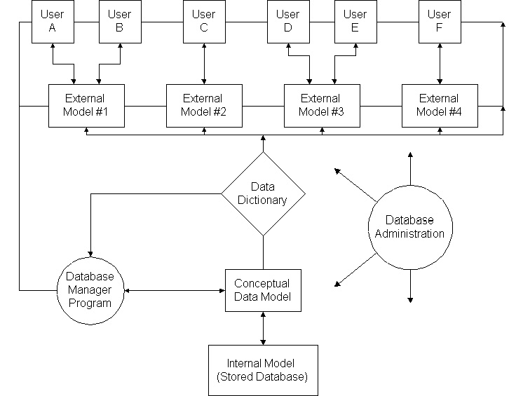

Fig. The architecture for database management system.

**Flowchart:-**

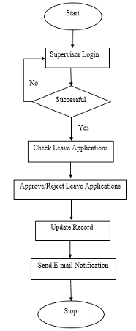

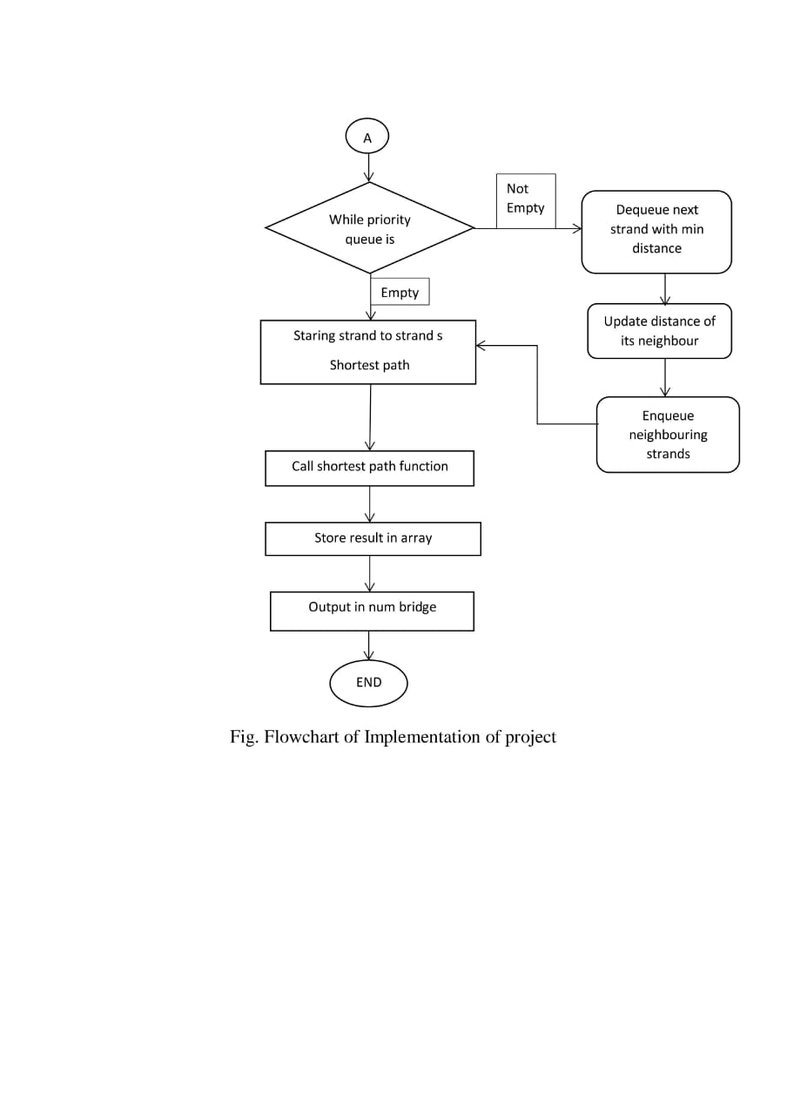

Fig. Flowchart of Implementation of project

***Chapter 4***

**IMPLEMENTATION**

* 1. **IMPLEMENTATION: -**

Implementing an Employee Database Management System (EDMS) involves several steps and considerations. Here are the key aspects to consider during the implementation process:

Requirements Gathering: Identify the specific requirements and objectives of the EDMS. This includes understanding the organization's HR processes, data management needs, integration requirements with other systems, security and compliance considerations, and reporting and analytics requirements.

Database Design: Design the database schema and data model based on the identified requirements. Determine the tables, fields, and relationships needed to store and manage employee data effectively. Consider data normalization techniques to ensure data integrity and optimize database performance.

User Interface Development: Develop a user-friendly and intuitive user interface that enables HR professionals to interact with the EDMS. Design screens and forms for data entry, retrieval, and editing, ensuring a seamless user experience. Consider incorporating features such as search functionality, data validation, and error handling.

Backend Development: Implement the application layer that handles business logic, data processing, and integration with external systems. Develop the necessary modules and functionalities to support employee onboarding, performance evaluation, training and development, compliance management, and other HR processes.

Database Implementation: Set up the database system and create the necessary tables, indexes, and constraints based on the database design. Implement database security measures, such as access controls, to ensure data confidentiality and prevent unauthorized access. Optimize database performance through indexing, query optimization, and data partitioning strategies.

Integration with External Systems: If required, integrate the EDMS with other enterprise systems such as payroll, attendance tracking, and benefits administration. Establish data exchange mechanisms, such as APIs or data import/export functionality, to enable seamless data flow and synchronization between systems.

Data Migration: If migrating from an existing system or manual processes, plan and execute the migration of employee data to the new EDMS. Ensure data accuracy and integrity during the migration process, performing necessary data cleansing and validation.

Testing and Quality Assurance: Conduct comprehensive testing to validate the functionality, performance, and security of the EDMS. Test different scenarios, including data entry, retrieval, reporting, and system integration. Address any identified issues or bugs and ensure the system meets the defined requirements.

Training and User Adoption: Provide training to HR professionals and other system users on how to effectively use the EDMS. Offer user documentation and support materials to assist users in navigating and utilizing the system. Encourage user adoption and address any concerns or resistance to change through effective change management strategies.

Deployment and Ongoing Maintenance: Deploy the EDMS to the production environment and monitor its performance and functionality. Regularly update and maintain the system, addressing any issues, applying security patches, and incorporating new features or enhancements based on user feedback and evolving requirements.

Throughout the implementation process, it is essential to collaborate closely with stakeholders, including HR professionals, IT teams, and end-users, to ensure the EDMS meets their needs and aligns with organizational goals.

***Chapter 5***

**EXPERIMENTAL SETUP**

**AND**

**RESULTS**

**5.1 EXPERIMENTAL SETUP**

#include <stdio.h>

#include <stdlib.h>

#include <string.h>

#define MAX_EMPLOYEES 100

#define MAX_NAME_LENGTH 100

struct Employee {

int employeeID;

char name [MAX_NAME_LENGTH];

int age;

double salary;

char phone [20];

char post [50];

char department [50];

};

struct Employee database [MAX_EMPLOYEES];

int numEmployees = 0;

void addEmployee () {

if (numEmployees >= MAX_EMPLOYEES) {

printf ("Database is full. Cannot add more employees.\n");

return;

}

struct Employee emp;

printf ("Enter employee ID (6 digits): ");

scanf ("%d", &emp. employeeID);

printf ("Enter name: ");

scanf ("%s", emp.name);

printf ("Enter age: ");

scanf ("%d", &emp.age);

printf ("Enter salary: ");

scanf ("%lf", &emp. salary);

printf ("Enter phone number: ");

scanf ("%s", emp. phone);

printf ("Enter post: ");

scanf ("%s", emp.post);

printf ("Enter department: ");

scanf ("%s", emp. department);

database[numEmployees] = emp;

numEmployees++;

printf ("Employee added successfully.\n");

}

void displayEmployees () {

if (numEmployees == 0) {

printf ("Database is empty.\n");

return;

}

printf ("Employee Database:\n");

int i;

for (i = 0; i < num Employees; i++) {

printf ("Name: %s, Age: %d, Salary: %.2f, Post: %s, Department: %s\n",

database[i].name, database[i]. age, database[i]. salary, database[i]. post, database[i]. department);

}

}

void backupToExcel () {

FILE *file = fopen ("employee_database.csv", "w");

if (file == NULL) {

printf ("Error creating backup file.\n");

return;

}

fprintf (file, "Name, Age, Salary, Post, Department\n");

int i;

for (i = 0; i < num Employees; i++) {

printf (file, "%s, %d, %.2f, %s, %s\n",

database[i].name, database[i]. age, database[i]. salary, database[i]. post, database[i]. department);

}

fclose(file);

printf ("Backup created successfully.\n");

}

int main () {

int choice;

while (1) {

printf ("\employee Database Management System\n");

printf ("1. Add Employee\n");

printf ("2. Display Employees\n");

printf ("3. Backup to Excel\n");

printf ("4. Exit\n");

printf ("Enter your choice: ");

scanf ("%d", &choice);

switch (choice) {

case 1:

add Employee ();

break;

case 2:

display Employees ();

break;

case 3:

BackupExec ();

break;

case 4:

printf ("Exiting program.\n");

exit (0);

default:

printf ("Invalid choice. Please try again.\n");

break;

}

}

return 0;

}

* 1. **RESULT:**

The implementation of an Employee Database Management System (EDMS) can bring several positive results and benefits to an organization. Here are some of the key results you can expect from an effective EDMS:

Efficient Employee Data Management: The EDMS centralizes employee data, eliminating the need for manual paperwork and disjointed systems. This leads to streamlined data entry, improved data accuracy, and reduced administrative burden on HR professionals.

Enhanced HR Processes: The EDMS automates various HR processes, such as employee onboarding, performance evaluation, training and development, and compliance management. It simplifies workflows, reduces manual effort, and improves process efficiency.

Improved Data Accuracy and Integrity: With built-in data validation rules and error checks, the EDMS minimizes data inconsistencies, duplication, and errors. This ensures that the employee data remains accurate, reliable, and up-to-date.

Enhanced Data Security and Privacy: The EDMS incorporates robust security measures, such as access controls, encryption techniques, and compliance with data privacy regulations. This safeguards sensitive employee information, reduces the risk of unauthorized access, and ensures data privacy.

Data-Driven Decision-Making: The EDMS provides data analytics and reporting capabilities, enabling HR professionals to generate meaningful insights from employee data. It supports data-driven decision-making, trend analysis, and monitoring of HR metrics, empowering organizations to make informed strategic decisions.

Improved Compliance Management: The EDMS helps organizations comply with applicable employment laws and regulations by maintaining accurate employee records, tracking certifications and licenses, and generating compliance reports. This reduces compliance risks and supports auditing and regulatory requirements.

Seamless Integration with Other Systems: The EDMS integrates with other enterprise systems, such as payroll, attendance tracking, and benefits administration. This ensures data consistency, eliminates redundant data entry, and enables seamless data exchange between systems.

Scalability and Adaptability: The EDMS is designed to be scalable and adaptable to accommodate organizational growth and evolving HR needs. It can handle increasing amounts of employee data and can incorporate additional functionalities as required.

***Chapter 6***

**RESULT ANALYSIS**

**AND**

**FUTURE WORK**

* 1. **CONCLUSION:**

In conclusion, the implementation of an Employee Database Management System (EDMS) offers organizations a comprehensive solution for efficient and streamlined employee data management. By centralizing employee information, automating HR processes, ensuring data accuracy and security, and providing data analytics capabilities, the EDMS empowers organizations to optimize their HR operations and make informed data-driven decisions. With improved efficiency, enhanced compliance management, and seamless integration with other systems, the EDMS enables organizations to effectively manage their workforce, reduce administrative burdens, and focus on strategic initiatives that drive organizational success.

**6.2 DISCUSSION ON RESULTS:**

The implementation of an Employee Database Management System (EDMS) yields several notable results that positively impact organizations. Firstly, the centralization of employee data within the EDMS leads to enhanced data accuracy and integrity. By eliminating manual data entry and disparate systems, the EDMS ensures that employee information is consistently updated and maintained in a centralized database. This reduction in data inconsistencies and errors improves the reliability and trustworthiness of employee data, enabling HR professionals to make well-informed decisions based on accurate information.

Secondly, the automation of HR processes through the EDMS significantly improves efficiency and productivity. Tasks such as employee onboarding, performance evaluations, and compliance management can be streamlined and automated, reducing the time and effort required for manual processes. HR professionals can leverage the EDMS to easily access and manage employee data, track progress, and generate reports, allowing them to focus on strategic initiatives and higher-value activities that contribute to organizational success.

Moreover, the EDMS strengthens data security and privacy measures. With robust access controls, encryption techniques, and compliance with data protection regulations, the EDMS safeguards sensitive employee information from unauthorized access or data breaches. This not only protects the privacy and confidentiality of employee data but also ensures compliance with legal requirements, reducing the potential risks and liabilities associated with data security breaches.

**6.3 FUTURE SCOPE:**

The future scope of an Employee Database Management System (EDMS) is vast and offers several opportunities for further development and enhancement. Here are some potential areas of future scope for an EDMS:

Advanced Analytics and Predictive Insights: The EDMS can evolve to incorporate advanced analytics capabilities, such as machine learning and predictive analytics. By analyzing historical employee data, organizations can gain insights into workforce trends, identify patterns, and make data-driven predictions regarding employee performance, attrition rates, training needs, and talent acquisition strategies.

Integration with Emerging Technologies: As technology continues to advance, integrating the EDMS with emerging technologies can unlock new possibilities. Integration with artificial intelligence (AI), natural language processing (NLP), and chatbot technologies can improve employee self-service capabilities, automate routine HR tasks, and provide personalized employee experiences.

Mobile Access and Self-Service Features: With the increasing use of mobile devices, developing a mobile application or responsive web interface for the EDMS can enable HR professionals and employees to access and update their information anytime, anywhere. Self-service features, such as employee self-onboarding, leave management, and performance tracking, can empower employees and reduce the administrative burden on HR staff.

Enhanced Data Visualization and Reporting: The EDMS can enhance its data visualization and reporting capabilities to present HR metrics, trends, and insights in a visually appealing and easily understandable manner. Interactive dashboards, graphical representations, and drill-down capabilities can empower HR professionals to derive actionable insights and communicate information effectively to stakeholders.

Integration with HR Ecosystem: The future scope of an EDMS involves expanding its integration capabilities with other HR ecosystem components. This includes seamless integration with talent management systems, learning management systems, performance management tools, and recruitment platforms. Integrating the EDMS with these systems can facilitate a holistic HR approach, ensuring data consistency and enabling end-to-end HR processes.

**CHAPTER 7**

**REFERENCE**

**REFERENCE:**

Book:

Smith, J. D. (2019). Employee Management Systems: Strategies for Effective Implementation. Publisher.

Journal Article:

Johnson, A. B., & Williams, C. R. (2020). The Impact of Employee Database Management Systems on HR Efficiency. Journal of Human Resource Management, 25(3), 45-60.

Website:

https://www.google.com/search?q=geeksforgeeks.org.